FOLDER: DATA/ORV

FILE: ORV_EUROPE_WGS84

* Description: ORV campaigns from 1983 to 2016, spatial polygon dataframe.
* Scripts: 4_Exploration_ORV, 4B_Subset_ORV_DEU_CZ_and_POL
* Output: plots, europe_ORV.shp and europe_ORV.csv files of whole Europe with a list of vaccinations. subset_ORV.shp, subset_ORV.csv and subset_ORV.klm files for with Germany, Czech Rep and Poland only.

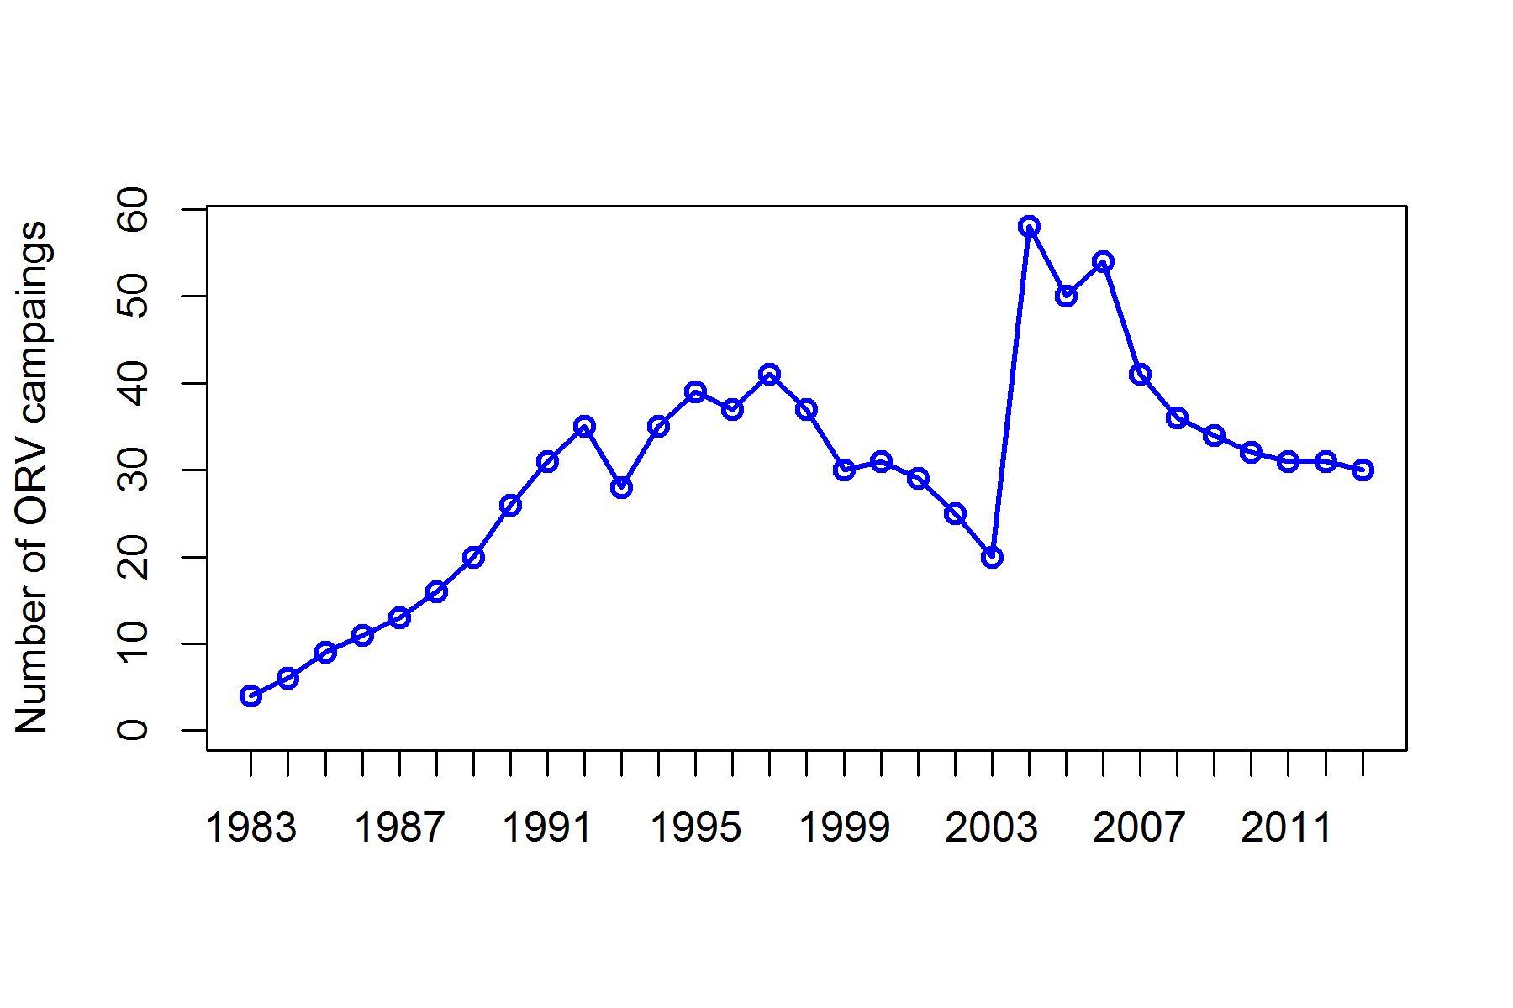

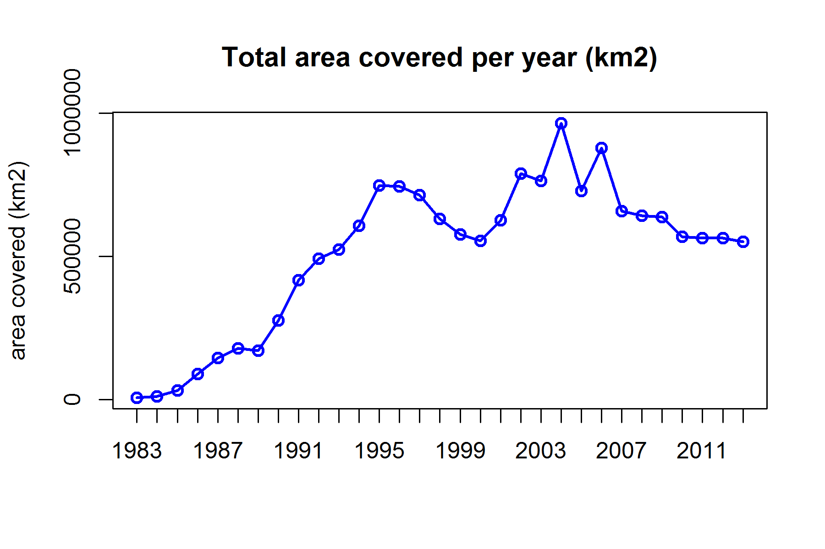

# By country

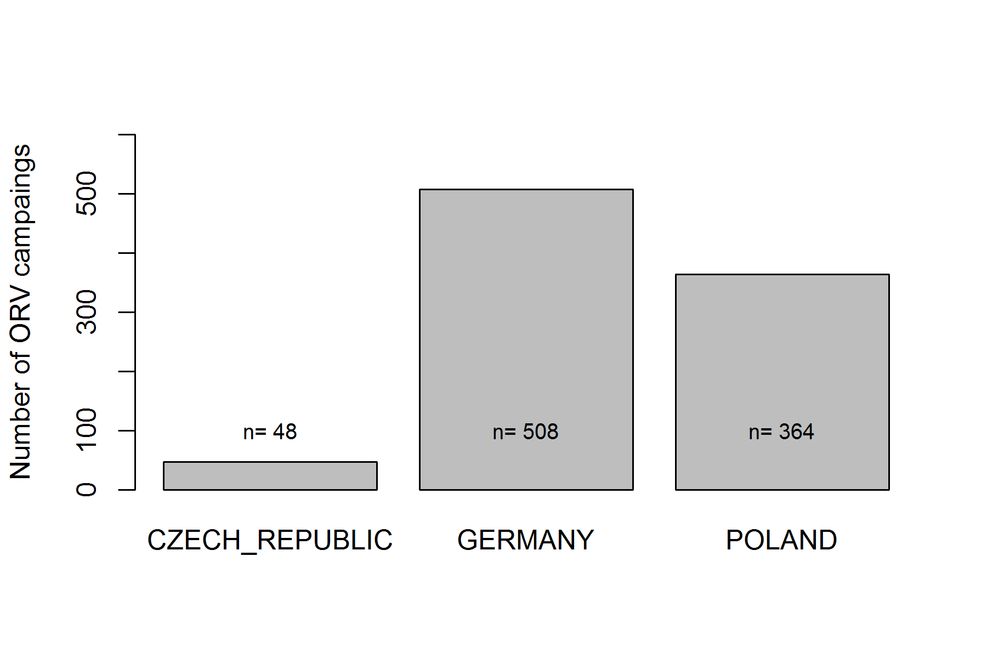

# By season

